# 

# **PROJECT PROPOSAL REPORT**

# **WILD VERVE**

# 

# **TEAM Name**

Bohao Su - 29392179

Chenyang Qiu - 29791359

Pranav Sharma -

Sandeep Sanjeev - 29908841

8/4/2020

Version 3

# **VERSION CONTROL**

|  |  |  |  |
| --- | --- | --- | --- |
| **Version** | **Date** | **Team Member** | **Detail** |
| version 1 | 03/04 | All |  |
| version 1.1 |  |  |  |
| version 1.2 | 06/04 | Chenyang Qiu | PACT analysis, layout |
| version 2 |  |  |  |
| version 2.1 | 08/04 | Chenyang Qiu | PACT analysis, layout, version control |
|  |  |  |  |
|  |  |  |  |
|  |  |  |  |

**Team name/Team Introduction in 1 page/ Photo update B&P/Header & Footer/Industry Meeting Minutes/ Dod**

# 

# **EXECUTIVE OVERVIEW**

International tourism in Victoria is increasing every year, with average visitors of three million per year. Australia is known to have exotic, rare, deadly and venomous wild animals. Due to the rarity of these animals, and information on the internet are vague and scattered, international tourists have a difficult time in spotting these animals and leads to intensifying curiosity. There are around 254 wild animal attack deaths every year in Victoria (Gemma, 2016). With the majority of the casualties being adult international tourists. These attacks occur mainly due to the lack of information of the animals and its nature among highly curious tourists. This project proposal report aims to provide a solution for an informative and blissful experience for the international tourists by providing information on the exotic animals in Victoria, to help the international tourists to locate these animals and understand the nature of these animals to avoid unfortunate situations.

The project solution proposed is to create a web-based application that will provide all information necessary on the exotic animals of Victoria in one place. It lets the user know the potential locations where the specific animal can be spotted. It provides the user with information regarding nature of the animal which is whether the animal is docile or aggressive, the diet of the animal so that tourists do not feed harmful food to the animal , approachability and precautionary measures to abide by when encountering the animal to keep the animal and tourist away from danger.

# 

# **TABLE OF CONTENT**

**PROJECT PROPOSAL REPORT** **1**

**WILD VERVE** **1**

**TEAM Name/ Header/ Footer/ Photo B&P** **1**

**VERSION CONTROL** **2**

**EXECUTIVE OVERVIEW** **2**

**TABLE OF CONTENT** **4**

**1. TEAM INTRODUCTION** **5**

**2. INTRODUCTION AND PROJECT DESCRIPTION** **6**

2.1 PURPOSE 6

2.2 BACKGROUND 7

2.3 CHALLENGE 7

2.4 SOLUTION 7

2.5 PACT ANALYSIS 7

**2.6 LEAN CANVAS** **9**

**2.7 SYSTEM ARCHITECTURE** **10**

**2.8 CONSIDERED AND PROPOSED EPICS** **11**

**2.9 ASSUMPTIONS** **11**

**2.9.1 Risks** **12**

**3. SECURITY ASPECTS TO BE COVERED** **12**

**3.1 OPEN DATA DETAILS** **13**

**3.2 APPENDICES** **13**

# **1. TEAM INTRODUCTION**

|  |  |
| --- | --- |
| **MEMBER NAME** | **BIO DESCRIPTION** |
| **Chenyang Qiu** | **Course**: Master of Information Technology  **Skills**: scheduling, coding  Have working experience in a real estate company, have time management skills and be ready to help others. Aim at designing a helpful application for people in the future. |
| **Sandeep Sanjeev** | **Course**: Master of Data Science  **Skills**: Data analysis  Aspiring Data Analyst looking forward to working with the team and enhancing my skills and capabilities by effectively contributing to the deliverables of the project. |
| **Pranav Sharma** | **Course:** Master of Business and Information systems  With prior experience in the commerce and marketing field. An efficient person aiming to leverage a proven knowledge of Project management, User Interface and System Design. Skills including visualisation, UI design and information systems. Business development skills to help prosper as a Business Analyst. With adaptable nature and hardworking personality. |
| **Bohao Su** | **Course**: Master of Information Technology  **Skills:** Java, SQL, C#, NETBEAN  MIT student with economics bachelor background. I have worked in luxury retail for more than one year. Good at teamwork and also a faster listener. Aiming to assist our teammates to finish our project effectively. |

# 

# **2. INTRODUCTION AND PROJECT DESCRIPTION**

## **2.1 PURPOSE**

The vital purpose of this project proposal report is to propose a project that will help improve the overall experience of Victorian tourism and avoid unfortunate encounters between tourists and wild animals. International tourists have a difficult time in gathering information on where to spot the exotic animals in Victoria. The information on the internet is scattered in different webpages and does not have all the information in one place. Due to this even though when tourists spot the animals, they do not know the information about each animal and do not know how to handle the situation without agitating the animal. A lot of these scenarios can lead to the animal becoming defensive resulting in casualties on both sides. Therefore, this project proposal aims to provide a reasonable solution to the above mentioned scenarios.

## **2.2 BACKGROUND**

Australian wild animals are adorable, however underestimating them may cause tragedy. Between 2000 and 2010, 254 human deaths were related to animals in Australia (Gemma, 2016). Since more travelers are coming to Australia and wish to have a closer look with local animals, they need to know the rules when getting along with them, and be well-prepared for the potential danger.

## **2.3 CHALLENGE**

Adult tourists are not able to get enough knowledge about Victorian wild animals because of the vague and widespread information on the internet, they have difficulties on spotting a specific animal and are likely to be attacked by aggressive animals.

## **2.4 SOLUTION**

The solution proposed in this report is a website based application that will provide the following functions:

* Provide possible location details of exotic animals in Victoria.
* Provide information on the animal’s nature whether it is docile or aggressive.
* Provides information on the conservation status of the animal and the rules to abide by given the status.
* The website will grant precautionary information on how to deal with the situation when encountering a potentially aggressive animal so that both the user and animal are safe.

## **2.5 PACT ANALYSIS**

|  |  |  |  |
| --- | --- | --- | --- |
| **People Analysis**  **Physical Characteristics**   * Age: From 18 to 50 * Gender: Both Male and Female * Hobby: travel to other countries, interact with wild animal   **Cognitive Characteristics**  Able to use the web application  **Experience & Expectations**  Have little knowledge about wild animals in Victoria, including but not limited to nature, local rules, distribution and precautionary information  **Language**  Basic English Level is preferred | **Activities Analysis**  **Animal Information Search**  By typing the name of animal, users can learn the necessary knowledge about interacting with the Victorian animals.  **Animal Distribution**  Wild Verve provides the function of spotting animals on the map for users to come and see them.  **Comment Function**  Users are able to leave comments on the animal information page to share their experience with others. | **Context Analysis**  **Physical Context**  All the activities can be done in any area by using devices with internet connection.  **Social Context**  Wild Verve aims to provide the same service for every user, different devices can be used to access the website, the user interface can be adjusted for different screens.  **Organizational Context**  Wild Verve is designed for personal and non-profit use. | **Technology Analysis**  **Input**  Mouse, keyboard, touch screen  **Output**  Screen, monitor  **Front-End**  JavaScript, HTML?  **Back-end**  PHP,MySQL?  **Database**  MySQL is the primary choice for scalability and high performance. |

# **2.6 LEAN CANVAS**

# 

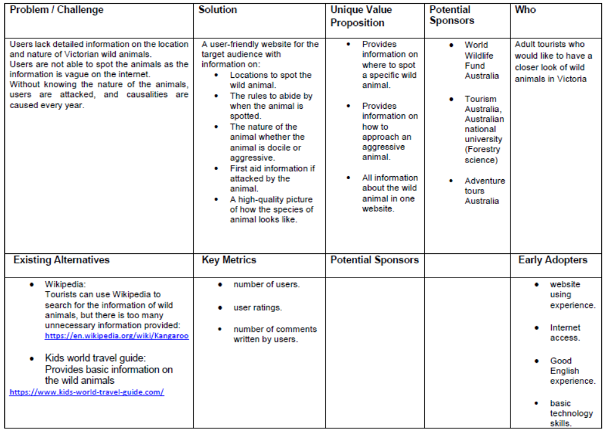

# 

# 

# **2.7 SYSTEM ARCHITECTURE**

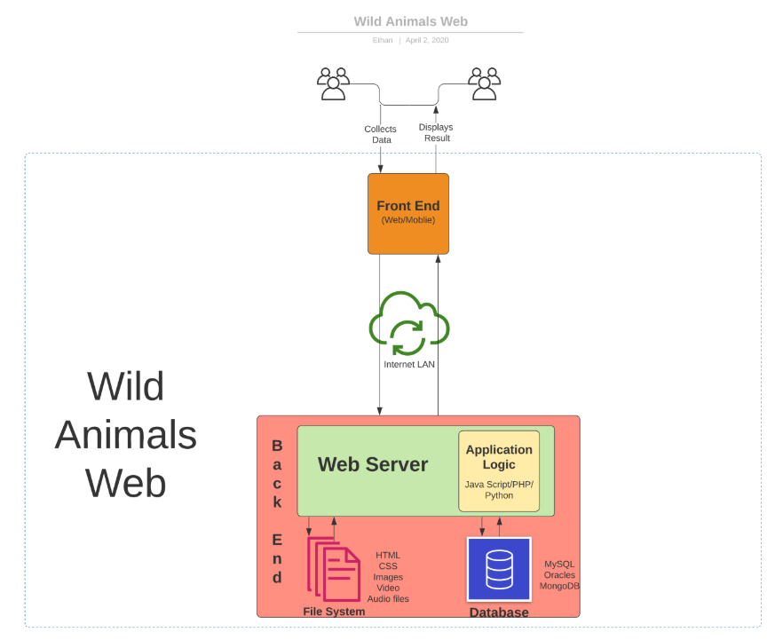

# 

# 

# **2.8 CONSIDERED AND PROPOSED EPICS**

* As a Teacher, I want to examine the endangered species, so that I can help students learn about wildlife.
* As a shutterbug, I want to know the location of the wild animal, so that I can take a clearer picture for them.
* As a father of a child, I want to know which animal could be agitated so that I can keep my kid away from them.
* As a millenial tourist, I want to know where to find koala bears and how to interact with them so I can take pictures with them.
* As a kid, I want to know the conservation status of wild animals so that I don’t feed them the food which will make them ill.
* As a road trip lover, I want to know where the wild animals will run across the road so that I will pay more attention when I am driving avoiding hitting them.
* As a Generation X foreign tourist, I want to know whether I have a chance of agitating wild animals so that I can avoid being hurt and protect myself.

# **2.9 ASSUMPTIONS**

There are certain assumptions that have been taken into consideration in respect of the project proposal. As the project revolves around being a wildlife expert, and for this the development of a website is done to let people be aware of different aspects of wildlife. Following are some of the assumptions:

**Users:** It is assumed that the users will have basic English reading knowledge and basic technology skills to access and use the website.

**Delivery:** Project/Website will work as per the desired functioning and will deliver an expected result. Correct information is displayed at the end of a search with the picture feature without any lag.

**Resources:** The resources required for the advanced research perspective are all present on this website. End users would be able to track and trace any and everything related to a particular animal. End users would not find it difficult to test the website.

**Scope and Technology:** The scope of the project to remain the same once the scope statement is agreed and signed. The technology to be considered is Python, HTML,CSS and word press; the testing would be done in an existing similar test environment.

## **2.9.1 Risks**

**Performance Risk:** The risk is associated with the project specifications. The project is vast and requires sources from multiple data sets. In the initial stage, it is easy for the website to perform as per the termed guidelines but as soon the specifications increases it will get difficult for the project to match the stated specifications.

**Information Security Risk:** The information secured in the project is at a risk of security breaches. Even the website will be at a risk of losing the data or destruction of information. Risks that come along with security are Improper use of the information and usage of the sources without proper acknowledgement.

# **3. SECURITY ASPECTS TO BE COVERED**

**User Confidentiality:** To ensure and save the entrance control and exposure limitations on data. Assurance that nobody will defy the guidelines of individual protection and restrictive data. So to secure the website in such a way that the user information as well as the data remains confidential.

**Integrate to the Website**: To conceal the inappropriate (unapproved) data adjustment or desolation. In addition, to integrate the data with the respective dataset to match the resource with the outlined information.

**Availability:** The data must be accessible to access and utilize constantly and with dependable access. Unquestionably, it simply should be valid for the individuals who have the right of access.

**Authorize:** To let the website define the rights and permissions for users/third parties.

Security controls are seen to restrict usefulness or meddle with ease of use; it is progressively harder to indicate what a framework ought not to do than what it ought to do.

# **3.1 OPEN DATA DETAILS**

|  |  |  |  |  |  |
| --- | --- | --- | --- | --- | --- |
| **Data Sources Open Data sets** | | | | | |
| **Names** | **Physical Access Used** | **Frequency of source updates** | **Frequency of Iteration System Updates** | **Granularity** | **Copyright details** |
| Exotic Australian Animals  <http://tiny.cc/mzpcmz> | CSV | Daily | Daily | Animal information | Open source |
| This is Australia - Species of National Environmental Significance Database which contains threatened and migratory species data .  <http://tiny.cc/08tcmz> | HTML | yearly | yearly | species data | Open source |
| This is a dataset about animal bites.  <http://tiny.cc/aducmz> | CSV | yearly | yearly | Animal bite data | open source |

# 

# **3.2 APPENDICES**

* <https://www.australiangeographic.com.au/topics/wildlife/2016/03/here-are-the-animals-really-most-likely-to-kill-you-in-australia/>
* <https://regions.ala.org.au/States%20and%20territories/VICTORIA#group=Mammals&subgroup=Herbivorous%20Marsupials&guid=&from=1850&to=2020&tab=speciesTab&fq=species_subgroup%3A%22Herbivorous%20Marsupials%22>

# 